# Wicab Sign Finder -- Build instructions

This file explains the steps involved in setting up the environment to build the SignFinder console application as well as building it. For more details, as well as for instructions on launching the application, please refer to the README.md file that is included with the source code, or the “Sign Finder Detection – Code Overview” document.

## Setting up and compiling

### Cloning the repository

The Sign Finder repository can be cloned from <https://bitbucket.org/skerisignfinder/wicab_signfinder>

### Installing CMake

In order to compile the source code you’ll need to download and install CMake (<http://www.cmake.org/download/>)

### **Dependencies**

In order to compile the software, the following dependencies need to be satisfied:

* OpenCV 2.4.11
* LibSVM 3.20

Install and compile OpenCV 2.4.11 ( <http://opencv.org/downloads.html>). After the installation, make sure that the directory containing the OpenCV libraries is included in the system path, otherwise a “library not found” error may happen at runtime.

Here you can find instruction on how to compile and install OpenCV: <http://docs.opencv.org/doc/tutorials/introduction/table_of_content_introduction/table_of_content_introduction.html>.

[Download LibSVM 3.20](https://www.csie.ntu.edu.tw/~cjlin/libsvm/) and extract the archive in your workspace. No installation or compilation are required for this library.

### Configuring the Sign Finder project

Launch CMake-gui. In the box “**Where is the source code**” put the location of your SignFinder working copy. In the box “**Where to build the binaries**” you can specify any folder. This is where the executable will appear after the compilation.

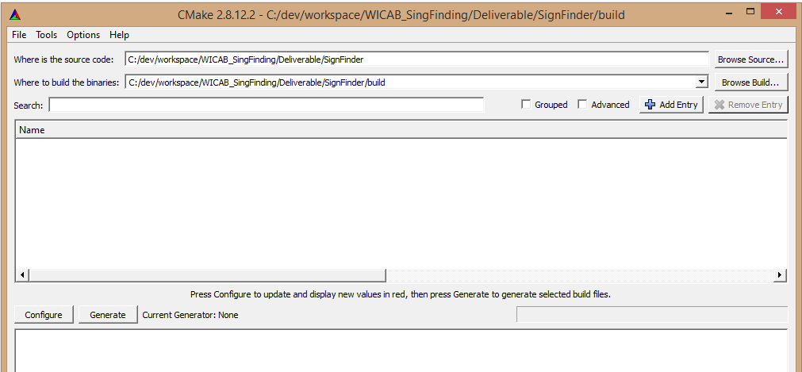

After setting up the folders, press the **Configure** button and when prompted choose the compiler you will be using to compile the code. If you set up everything correctly, this should appear:

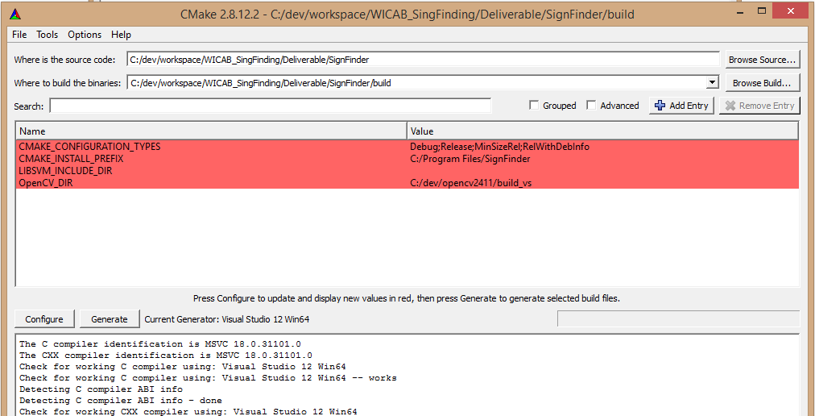

In LIBSVM_INCLUDE_DIR field, specify the location of LibSVM source code (the folder where svm.h and svm.cpp are). In the OpenCV_DIR field, specify the folder in which you put the compiled OpenCV libraries.

Press **Configure** again to update the configuration and then **Generate** to generate the makefile.

Now you’re ready to compile SignFinder using the compiler you selected earlier.

## Sign Finder - Configuration File

The SignFinder uses an external YAML file to specify the parameters of the object detector. We provided a configuration file for the detection of exit signs. The current configuration gives a good compromise between recall and computational time.

%YAML:1.0

# ATTENTION: DO NOT USE TAB CHARACTERS WHEN EDITING THIS FILE (you can replace tabs with spaces in you editor settings)

# Classifiers location

CascadeFile: "res/cascade.xml" # full path to cascade classifier CascadeFile

SVMFile: "res/exitModel.svm" # full path to SVM model

# Cascade search window parameters. It can be changed, but it is a good idea to keep the same aspect ratio (w/h = 1.5)

minWinSize:

width: 18

height: 12

CascadeScaleFactor: 1.1 # scale factor for multiscale detection

maxWinSizeFactor: 8. #specify largest search window as a multiple of minWinSize

# HOG

HOG_winSize: # DO NOT CHANGE: this parameter should be changed only if the SVM is trained with a different window size

width: 36

height: 24

SVMThreshold: .85 # sets the SVM confidence threshold

# Preprocessing

CroppingFactors: # specify which section of the image to process. Cropping origin is (0,0) i.e. top left corner

width: 1.0

height: 0.66

ScaleFactor: 0.66 # specify rescaling factor for cropped frames (helps with detection of small objects)

Flip: 1 # flip input frames (used for portrait vs landscape videos)

Transpose: 1 # transpose input frames (used for portrait vs landscape videos)

# Debug options

ShowIntermediate: 0

While the software is running, as the video plays, a window will show the detection results over each single frame in the video sequence in the form of one or more rectangles that highlight patches of the image in which the detection of a requested sign has occurred.